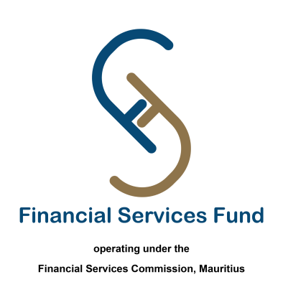

**Metro Wrapping Design Competition**

**Applicant details**

Full Name: [First Name] [Last Name]

Date of birth: [Date of Birth]

NIC: [National Identity Card]

Phone number: [Phone Number]

Address: [Address]

Email address: [Email Address]

Title of work: [Title of work]

**Metro Wrapping design details**

Title of your design: [Title]

Description and rationale of your design: [Description]

Maximum: [50 words]

**Design submission**

Send your design via WeTransfer

(FSF to confirm email or any other way of submission)

**Terms and Conditions**

I have read and agreed to the Terms and Conditions of the contest.

- [Link to Terms and Conditions]

**Design consent**

I consent to the use of my name and design images for promotional purposes related to the Metro Wrapping Design Contest. (Checkmark)

**Submission deadline**

By submitting this application, I confirm that all the information provided is accurate, and I understand that the deadline for submissions is **Thursday 30 November 2023**

Submit Application: [Submit Button]